MSW-11.42
5” Bass Midrange
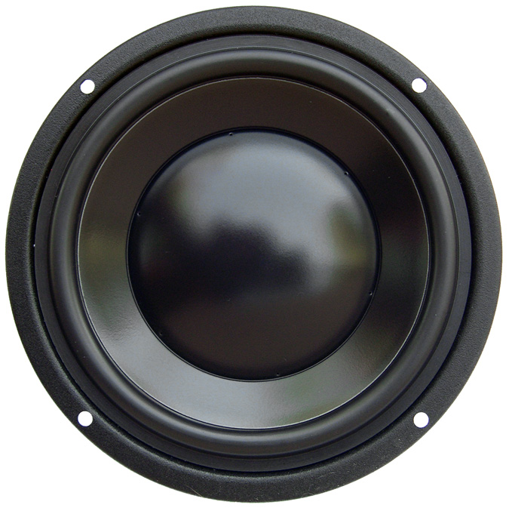

SPECIFICATIONS
Nominal Power Handling (RMS) |  | P | 150 W
Transient Power - 10 ms |  |  | 1,000 W
Nominal Impedance |  | Z | 8 Ω
Sensitivity 1W/1M |  |  | 86 dB
Frequency Response |  |  | 40 – 5,000 Hz
Resonant Frequency |  | FS | 45 Hz
VOICE COIL
Voice Coil Diameter |  | φ | 75mm (3.0”)
Voice Coil Height |  |  | 12 mm (0.47”)
Voice Coil Former |  |  | aluminum
Voice Coil Wire |  |  | hexagonal shaped aluminum
Number of Layers |  |  | 2
DC Resistance |  | RE | 5.2 Ω
Voice Coil Inductance @ 1 kHz |  | LBM | 0.38 mH
MAGNET SYSTEM
Magnet System Type |  |  | double ferrite, vented
Magnetic Gap Height |  | HE | 5 mm (0.2”)
Flux Density |  | B | 0.62 T
BL Product |  | BXL | 5.90 NA
Max. Linear Excursion |  | X | ±3.5 mm (0.14”)
OPERATIONAL PARAMETERS
Suspension Compliance |  | CMS | 1,023 μM / newton
Mechanical Q Factor |  | QMS | 1.80
Electrical Q Factor |  | QES | 0.51
Total Q Factor |  | Q/T | 0.40
Mechanical Resistance |  | RMS | 1.915 Kg S⁻¹
Moving Mass |  | MMS | 12.2 g
Equivalent Cas Air Load |  | VAS | 11.70 L
Cone / Dome Material |  |  | damped polymer composite
Effective Piston Area |  | S | 90 cm²
Dimensions | Diameter  Cutout  Height  Mounting Depth |  | 142mm (5.60”)  121mm (4.76”)  61mm (2.40”)  56mm (2.20”)
Net Weight |  |  | 0.97 kg (2.1 lbs)

