MST-385
Soft Dome Tweeter
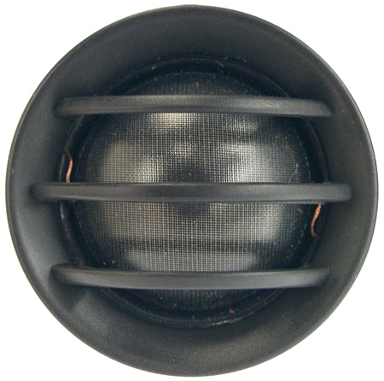

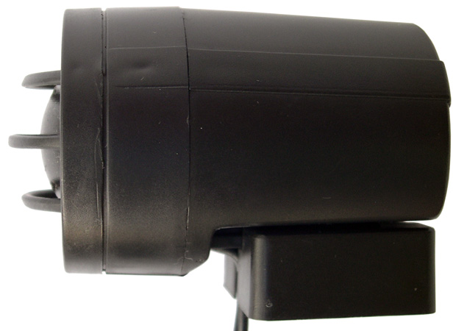

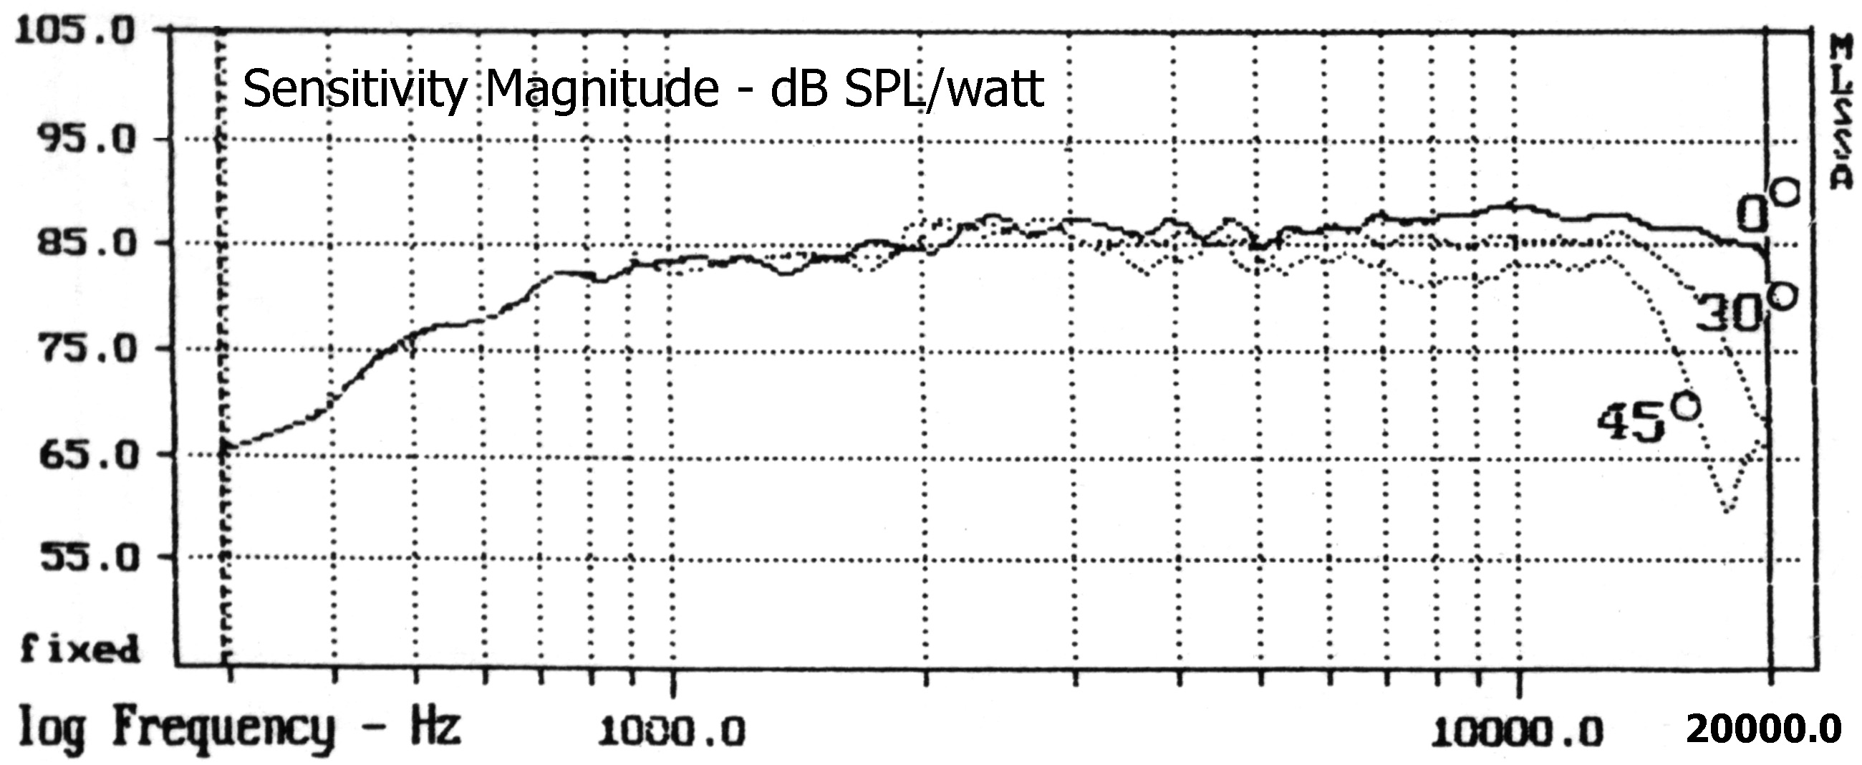

SPECIFICATIONS
Nominal Power Handling (RMS) |  | P | 80 W
Transient Power - 10 ms |  |  | 500 W
Nominal Impedance |  | Z | 8 Ω
Sensitivity 1W/1M |  |  | 89 dB
Frequency Response |  |  | 2,200 – 20,000 Hz
Resonant Frequency |  | FS | 750 Hz
VOICE COIL
Voice Coil Diameter |  | φ | 28 mm (1.1”)
Voice Coil Height |  |  | 2.5 mm (0.1”)
Voice Coil Former |  |  | aluminum
Voice Coil Wire |  |  | copper
Number of Layers |  |  | 2
DC Resistance |  | RE | 5.2 Ω
Voice Coil Inductance @ 1 kHz |  | LBM | 0.06 mH
MAGNET SYSTEM
Magnet System Type |  |  | neodymium, vented
Magnetic Gap Height |  | HE | 2.5 mm (0.1”)
Flux Density |  | B | 1.4 T
BL Product |  | BXL | 2.6 NA
OPERATIONAL PARAMETERS
Suspension Compliance |  | CMS | -
Mechanical Q Factor |  | QMS | -
Electrical Q Factor |  | QES | -
Total Q Factor |  | Q/T | -
Mechanical Resistance |  | RMS | -
Moving Mass |  | MMS | 0.46 g
Equivalent Cas Air Load |  | VAS | -
Cone / Dome Material |  |  | hand treated fabric
Effective Piston Area |  | S | 7 cm²
Dimensions | Diameter  Length |  | 44mm (1.73”)  58mm (2.28”)
Net Weight |  |  | 0.09 kg (0.2 lbs)
MST-395
Soft Dome Tweeter
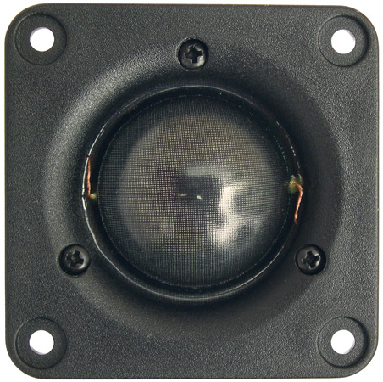
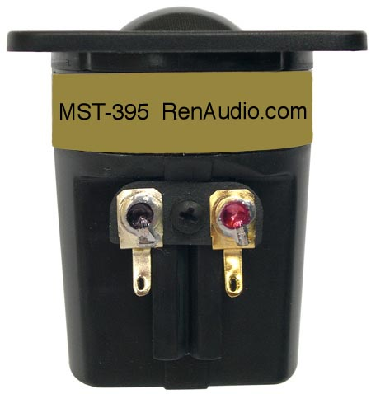
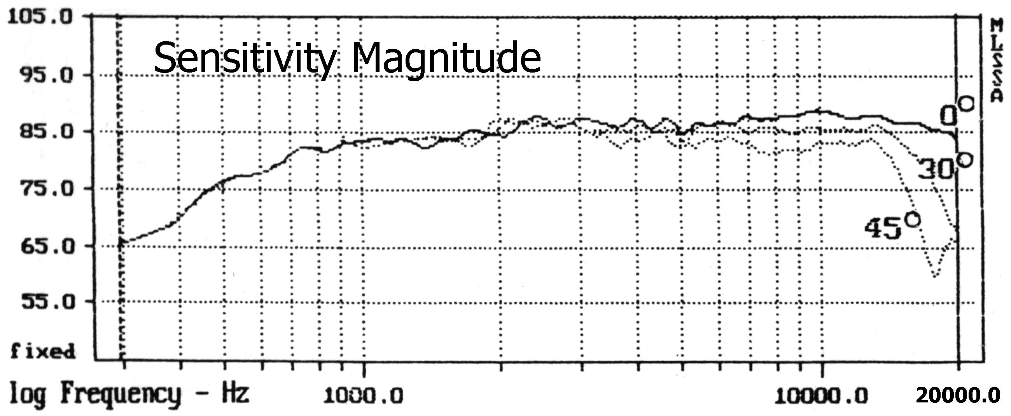

SPECIFICATIONS
Nominal Power Handling (RMS) |  | P | 80 W
Transient Power - 10 ms |  |  | 500 W
Nominal Impedance |  | Z | 8 Ω
Sensitivity 1W/1M |  |  | 88 dB
Frequency Response |  |  | 2,200 – 20,000 Hz
Resonant Frequency |  | FS | 750 Hz
VOICE COIL
Voice Coil Diameter |  | φ | 28 mm (1.1”)
Voice Coil Height |  |  | 2.5 mm (0.1”)
Voice Coil Former |  |  | aluminum
Voice Coil Wire |  |  | copper
Number of Layers |  |  | 2
DC Resistance |  | RE | 5.2 Ω
Voice Coil Inductance @ 1 kHz |  | LBM | 0.06 mH
MAGNET SYSTEM
Magnet System Type |  |  | neodymium, vented
Magnetic Gap Height |  | HE | 2.5 mm (0.1”)
Flux Density |  | B | 1.4 T
BL Product |  | BXL | 2.6 NA
OPERATIONAL PARAMETERS
Suspension Compliance |  | CMS | -
Mechanical Q Factor |  | QMS | -
Electrical Q Factor |  | QES | -
Total Q Factor |  | Q/T | -
Mechanical Resistance |  | RMS | -
Moving Mass |  | MMS | 0.46 g
Equivalent Cas Air Load |  | VAS | -
Cone / Dome Material |  |  | hand treated fabric
Effective Piston Area |  | S | 7 cm²
Dimensions | Diameter  Length  Faceplate Thickness |  | 54mm (2.13”)  58mm (2.28”)  3mm (0.12”)
Net Weight |  |  | 0.09 kg (0.2 lbs)

