MSW-1220
8” Paper Cone Woofer

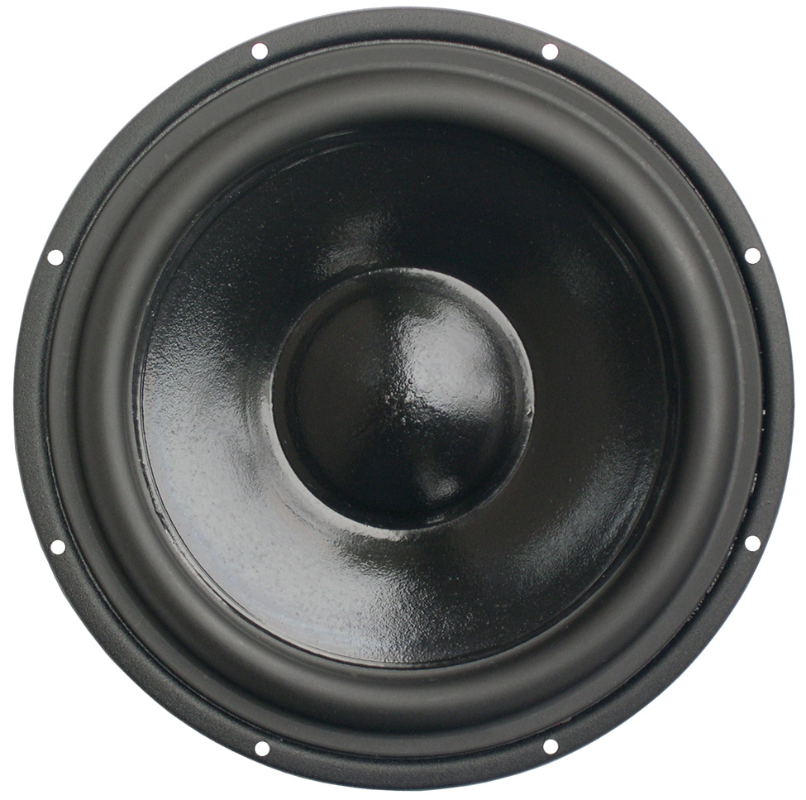

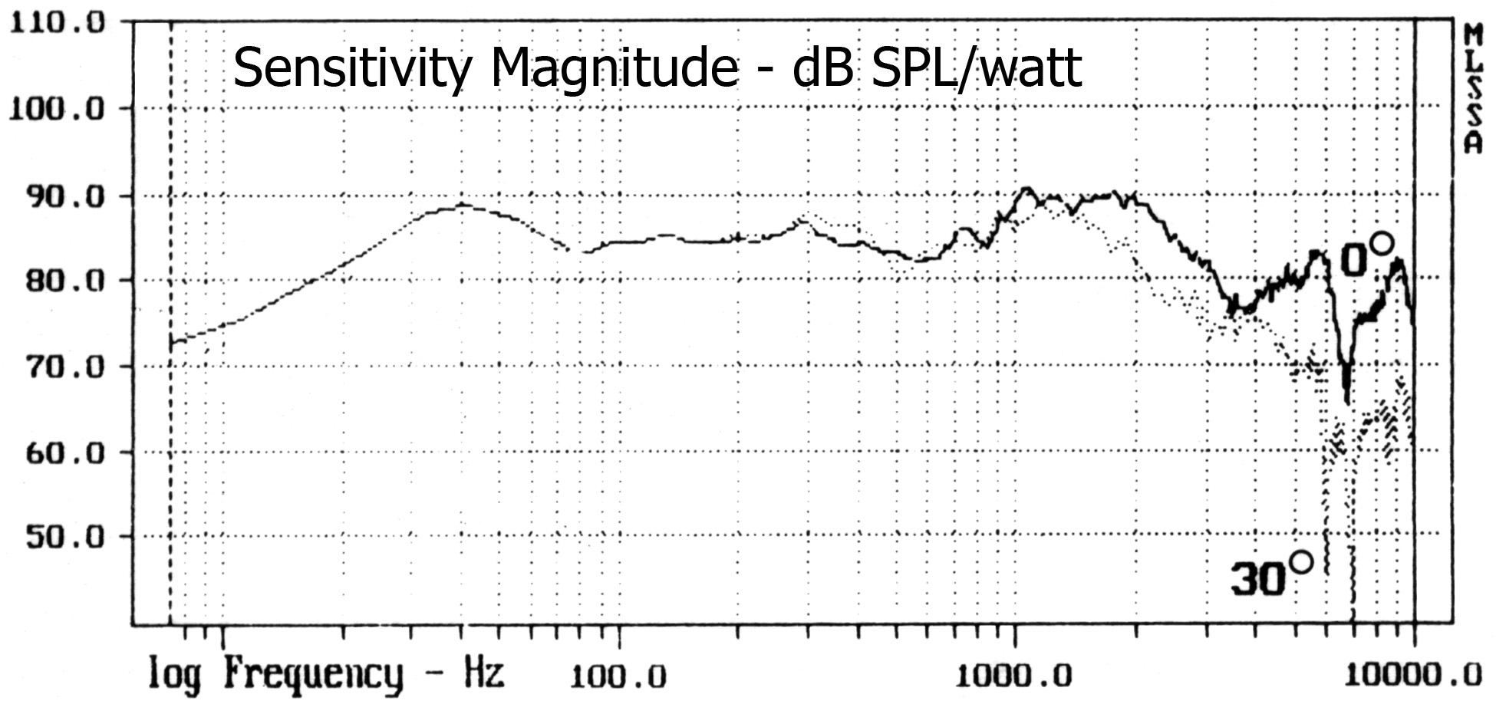

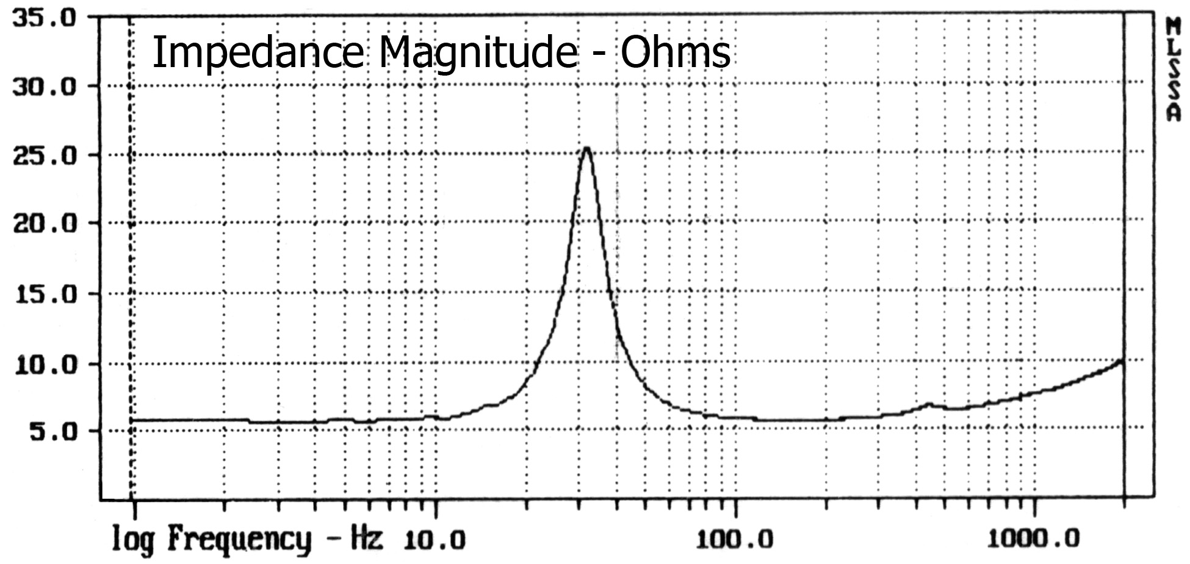

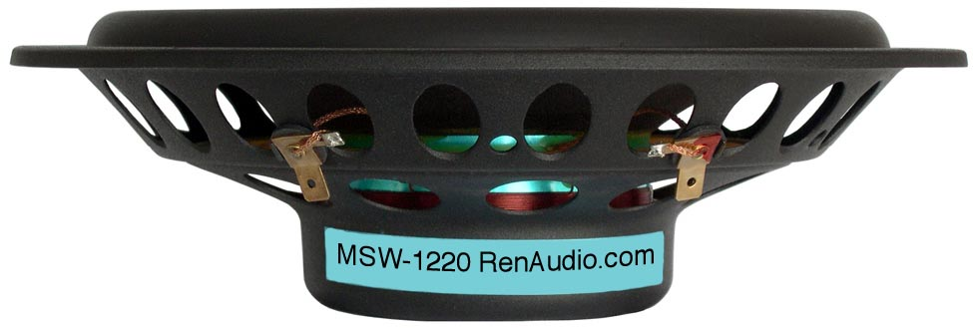

SPECIFICATIONS
Nominal Power Handling (RMS) |  | P | 120 W
Transient Power - 10 ms |  |  | 1,000 W
Nominal Impedance |  | Z | 8 Ω
Sensitivity 1W/1M |  |  | 89 dB
Frequency Response |  |  | 30 – 2,300 Hz
Resonant Frequency |  | FS | 31 Hz
VOICE COIL
Voice Coil Diameter |  | φ | 75mm (3”)
Voice Coil Height |  |  | 12 mm (0.47”)
Voice Coil Former |  |  | aluminum
Voice Coil Wire |  |  | hexagonal shaped aluminum
Number of Layers |  |  | 2
DC Resistance |  | RE | 5.2 Ω
Voice Coil Inductance @ 1 kHz |  | LBM | 0.5 mH
MAGNET SYSTEM
Magnet System Type |  |  | ferrite
Magnetic Gap Height |  | HE | 5.0 mm (0.20”)
Flux Density |  | B | 0.55 T
BL Product |  | BXL | 5.1 NA
Max. Linear Excursion |  | X | ±3.5 mm (0.14”)
OPERATIONAL PARAMETERS
Suspension Compliance |  | CMS | -
Mechanical Q Factor |  | QMS | 3.74
Electrical Q Factor |  | QES | 0.95
Total Q Factor |  | Q/T | 0.75
Mechanical Resistance |  | RMS | -
Moving Mass |  | MMS | 25 g
Equivalent Cas Air Load |  | VAS | 70 L
Cone / Dome Material |  |  | polymer doped paper
Effective Piston Area |  | S | 219 cm²
Dimensions | Diameter  Cutout  Height  Mounting Depth |  | 222mm (8.74”)  196mm (7.72”)  62.5mm (2.46”)  58mm (2.28”)
Net Weight |  |  | 0.90 kg (1.98 lbs)

